Event-Driven E-commerce Data Processing

# Introduction

Welcome to the Event-Driven E-commerce Data Processing tutorial. This guide will help you understand how to implement event-driven architecture using AWS ECS, Step Functions, DynamoDB, and EventBridge to process e-commerce data efficiently.

# Architecture Overview

Below is an overview of the architecture for processing e-commerce data:

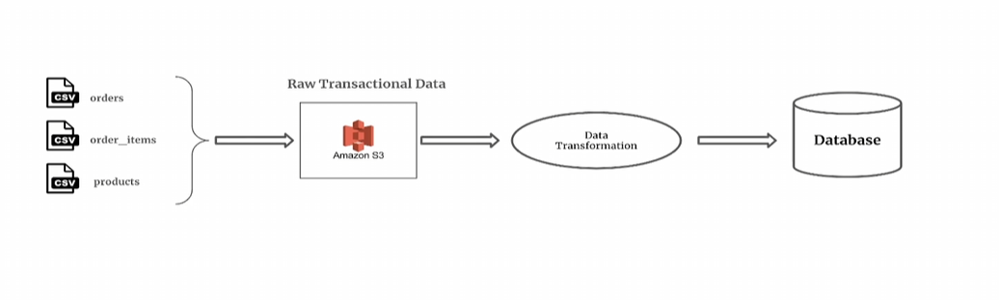

# Workflow Steps

The architecture follows these steps:  
1. Raw transactional data is uploaded to Amazon S3.  
2. AWS Step Functions triggers ECS Tasks based on new files in S3.  
3. The first ECS Task validates the dataset.  
4. If valid, another ECS Task processes the data and writes it into DynamoDB.  
5. EventBridge is used to automate triggering based on file uploads.

# Workflow Execution

